Teaching Staff List B.A. B.Ed.
Rajasthan Shikshak Prashikshan Vidyapeeth, Shahapura Bagh, Amer Road, Jaipur
S.No. | Name of Faculty | Designation | Date of Birth | Educational  Qualification | Total  Experience | Date of Joining | Subject | Whether Approved by the Affilating Univ./Body | Photo | Documents
1 | Dr. Manisha Sharma | Principal | 18.09.1981 | M.A.  B.Ed  M.Ed.  Ph.D.  PDF | 16 Years  08 Month | 12.02.2022 | English,  Psychology | YES | 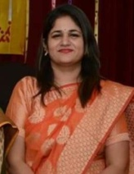 | https://rspv.org/wp-content/uploads/document/DR.-MANISHA-SHARMA.pdf
2 | Dr. Ram Prakash | Assistant Professor  (HOD) | 08.07.1964 | M.A../MSC, M.A.  B.Ed.  M.Ed, PHD  Ph.D | 31 Years | 09.1.2023 | Economics,  Geography | NO | 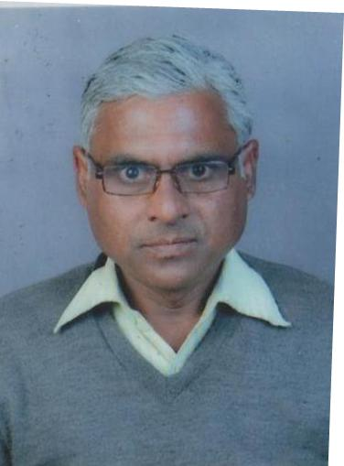 | https://rspv.org/wp-content/uploads/document/RAM-PRAKASH-JI.pdf
3 | Dr. Seema Kundra | Associate professor | 20.01.1980 | M.A.  B.Ed.  M.Ed, NET  Ph.D | 12 Years | 24.02.2018 | History | YES | 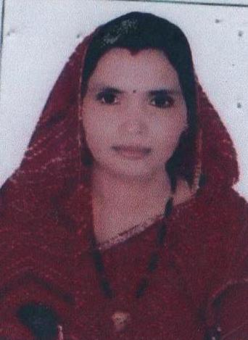 | https://rspv.org/wp-content/uploads/document/seema-kundara.pdf
4 | Mr. Subhash Meena | Assistant Professor | 06.01.1973 | M.A..  B.Ed.  M.Ed, NET | 15 Years  05 Month  11 Day  College | 24.02.2018 | Philosophy  Sociology  Social Study  Civics | YES | 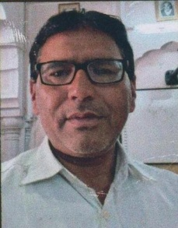 | https://rspv.org/wp-content/uploads/document/SUBHASH-MEENA.pdf
5 | Dr. Sanjay Goswami | Associate professor | 03.07.1968 | M.A..  B.Ed.  M.Ed  Ph.D. | 06 Years  09 Month  03 Day  College | 01.07.2019 | Sanskrit | YES | 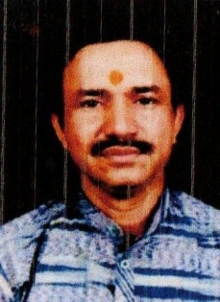 | https://rspv.org/wp-content/uploads/document/Sanjay-Goswami.pdf
6 | Mr. Shriram Jaat | Assistant Professor | 11.06.1988 | M.A..  B.Ed.  M.Ed,  NET | 02 Years  04 Month  21 day college | 29.11.2021 | Geography | NO | 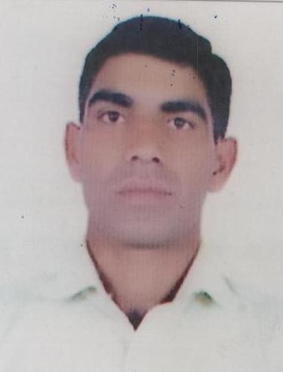 | https://rspv.org/wp-content/uploads/document/SHRIRAM-JAT.pdf
7 | Mr. Jailal Jatav | Assistant Professor | 16.08.1981 | M.A..  B.Ed.  M.Ed  NET | 02 Years  04 Month  05 day college | 15.12.2021 | Sanskrit | NO | 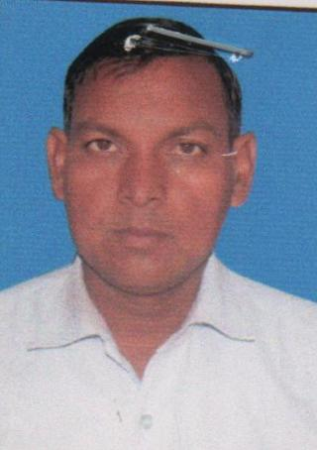 | https://rspv.org/wp-content/uploads/document/Jailal-jatav.pdf
8 | Ms. Sangeeta Shrama | Assistant Professor | 15.08.1976 | M.A  B.Ed  M.Ed  NET | 08 Year  09 Month  22 Day  College | 01.1.2020 | Economics | NO | 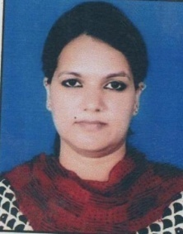 | https://rspv.org/wp-content/uploads/document/Sangeeta-Sharma.pdf
9 | Ms. Vranda Haldia | Assistant Professor | 07.12.1992 | M.V.A  NET | 06 Years  01 Month 24 day  College | 24.02.2018 | Art & Crafts | YES |  | https://rspv.org/wp-content/uploads/document/Vrinda-Haldia.pdf
10 | Dr. Kanchan Gupta | Assistant Professor | 24.01.1986 | M.A., Music, B.ED, NET Ph.D | 1 Year  2 Month  27 Day  College | 23.01.2023 | Music | NO |  | https://rspv.org/wp-content/uploads/document/kanchan-gupta.pdf

