Teaching Staff List B.Ed.
Rajasthan Shikshak Prashikshan Vidyapeeth, Shahapura Bagh, Amer Road, Jaipur
S.No. | Name of Faculty | Designation | Date of Birth | Educational  Qualification | Total  Experience | Date of Joining | Subject | Whether Approved by the Affilating Univ./Body | Photo | Documents
1 | Dr. Manisha Sharma | Principal | 18.09.1981 | M.A.  B.Ed  M.Ed.  Ph.D.  PDF | 16 Years  08 Month | 12.02.2022 | English,  Psychology | YES |  | https://rspv.org/wp-content/uploads/document/DR.-MANISHA-SHARMA.pdf
2 | Dr. Pratibha Mishra | Assistant Professor | 10.08.1990 | M.A.  B.Ed.  M.Ed,  Ph.D.  NET | 09 Years  07 Month | 03.09.2014 | Social Study,  History | YES |  | https://rspv.org/wp-content/uploads/document/DR.-PRATIBHA-MISHRA.pdf
3 | Mrs. Meenakshi Joshi(Sharma) | Assistant Professor | 14.10.1987 | MA.  B.Ed.  M.Ed | 09 Years  05 Month | 09.05.2017 | Civics,  Social Study | YES |  | https://rspv.org/wp-content/uploads/document/MEENAKASHI-JOSHI.pdf
4 | Mr. Jeeterndra kumar Sharma | Assistant Professor | 25.06.1985 | M.A  B.Ed  M.Ed. | 07 year  09 Month | 23.06.2016 | Hindi,  Sanskrit | YES | 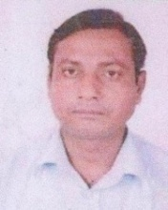 | https://rspv.org/wp-content/uploads/document/JEETENDRA-KUMAR-SHARMA.pdf
5 | Dr. Shiv lal Meena | Assistant Professor | 10.07.1983 | M.A  B.Ed  M.Ed  NET  Ph.D. | 04 Years  10 Month | 01-07-2019 | History | YES | 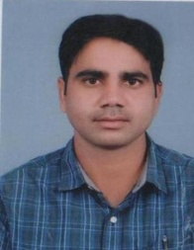 | https://rspv.org/wp-content/uploads/document/DR.-SHIV-LAL-MEENA.pdf
6 | Mr. Malkhan Meena | Assistant Professor | 15.08.1991 | M.A  B.Ed  M.Ed  NET | 03 Years  04 Month | 18.12.2020 | History | YES | 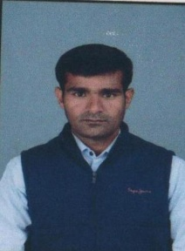 | https://rspv.org/wp-content/uploads/document/MALKHAN-MEENA.pdf
7 | Mrs. Pratistha Singh | Assistant Professor | 08.04.1990 | M.com  B.Ed  M.Ed  Net | 04 Month | 01.12.2023 | Book Keeping,  Commerce Practice | NO |  | https://rspv.org/wp-content/uploads/document/PRITHSHTA-SINGH.pdf
8 | Pooja Mathur | Assistant Professor | 22.01.1983 | M.Sc.  B.Ed.  M.Ed.  NET | 05 Month | 17.11.2023 | Gen. Science,  Chemistry | NO | 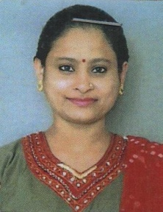 | https://rspv.org/wp-content/uploads/document/POOJA-MATHUR.pdf
9 | Dr. Khushbu Jain | Assistant Professor | 05.07.1982 | M.A.  B.Ed.  M.Ed.  NET  Ph.D. | 10 Months | 21.06.2023 | Economics,  English | NO |  | https://rspv.org/wp-content/uploads/document/DR.KHUSHU-JAIN.pdf
10 | Mr. Jagdish Prasad Bairwa | Assistant Professor | 09.08.1987 | M.A.  B.Ed.  M.Ed.  NET | 02 Year  02 Month | 11.02.2022 | Civics ,  Social Study | NO |  | https://rspv.org/wp-content/uploads/document/JAGDISH-BAIRWA.pdf
11 | Mr. Keshav Mishra | Assistant Professor | 26.10.1990 | M.A.  B.Ed.  M.Ed.  NET | 05 Month | 17.11.2023 | History  Social Study | NO | 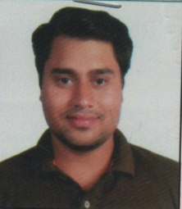 | https://rspv.org/wp-content/uploads/document/KESHAV-MISHRA.pdf
12 | Dr. Kavita Kumari Sharma | Assistant Professor | 05.07.1987 | M.A.  B.Ed.  M.Ed.  Ph.D. | 08 Years  02 Month | 26.12.2023 | Civics,  Social Study | NO | 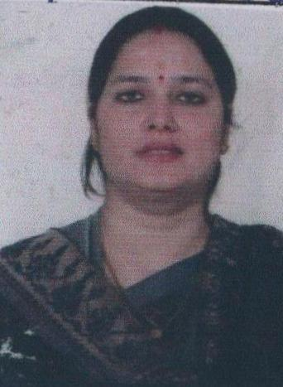 | https://rspv.org/wp-content/uploads/document/KAVITA-KUMARI-SHARMA.pdf
13 | Mrs. Jyotshna Kumari Verma | Assistant Professor | 07.07.1987 | M.A.  B.Ed.  M.Ed.  NET | 03 Month | 22.12.2023 | Sanskrit | NO |  | https://rspv.org/wp-content/uploads/document/JYOTSANA-KUMARI-VERMA.pdf
14 | Mr. Chand Bihari Bairwa | Assistant Professor | 04.07.1987 | M.A.  B.Ed.  M.Ed.  NET | 02 Year  02 Month | 11.02.2022 | History | NO | 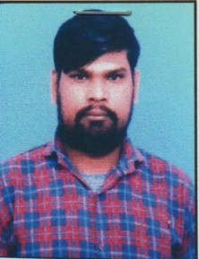 | https://rspv.org/wp-content/uploads/document/CHAND-BIHARI-BAIRWA.pdf
15 | Mr. Amit Sharma | Assistant Professor | 03.02.1986 | M.F.A.  (Panting) | 07 year  11 Month | 12.05.2016 | Visual Arts | YES | 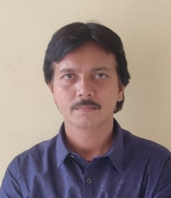 | https://rspv.org/wp-content/uploads/document/AMIT-SHARMA.pdf
16 | Mr. Satish Kumar | Assistant Professor | 01.01.1968 | M.A.  D.PEd.  M.PEd. | 32 Years  01 Month | 01.04.1992 | Physical Education  yoga | NO | 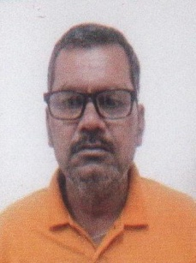 | https://rspv.org/wp-content/uploads/document/SATISH-KUMAR.pdf

